Chocolatey
# Source: AI Source: Provided by: [Data Path: Persons Table -> ID Column: 1, Name_En Column: Motasem Essam] -> From: [Chatgpt (GPT‑5 Mini)] on [1/26/2026]
Chocolatey is a package manager for Windows that allows you to install, update, and manage software from the command line — similar to how Linux uses apt or yum.

🍫 What Chocolatey Does:
# Source: AI Source: Provided by: [Data Path: Persons Table -> ID Column: 1, Name_En Column: Motasem Essam] -> From: [Chatgpt (GPT‑5 Mini)] on [1/26/2026]
It automates:
- Downloading software (e.g., Google Chrome, Git, VLC, Node.js)
- Installing it silently (no clicking "Next, Next, Finish")
- Managing updates
- Uninstalling software cleanly

✅ Why Use Chocolatey?
# Source: AI Source: Provided by: [Data Path: Persons Table -> ID Column: 1, Name_En Column: Motasem Essam] -> From: [Chatgpt (GPT‑5 Mini)] on [1/26/2026]
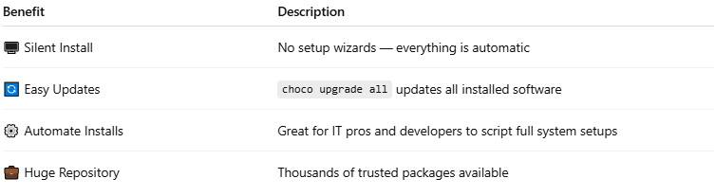

Benefit | Description
🖥️ Silent Install | No setup wizards — everything is automatic
🔄 Easy Updates | choco upgrade all updates all installed software
⚙️ Automate Installs | Great for IT pros and developers to script full system setups
💼 Huge Repository | Thousands of trusted packages available

📦 Example Commands
# Source: AI Source: Provided by: [Data Path: Persons Table -> ID Column: 1, Name_En Column: Motasem Essam] -> From: [Chatgpt (GPT‑5 Mini)] on [1/26/2026]
✅ Install a Package:
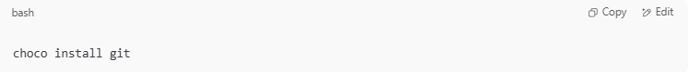
choco install git

🔄 Upgrade a Package:
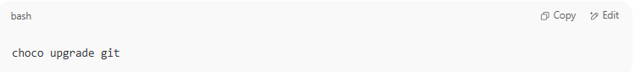
choco upgrade git

❌ Uninstall a Package:
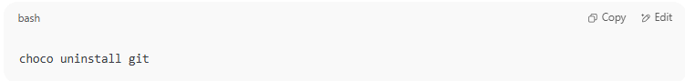
choco uninstall git

📚 Search for a Package:
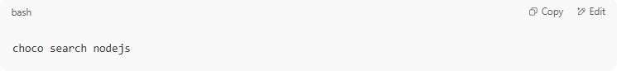
choco search nodejs

🔃 Upgrade All:
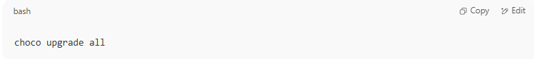
choco upgrade all

🧪 How to Install Chocolatey (1-time setup):
# Source: AI Source: Provided by: [Data Path: Persons Table -> ID Column: 1, Name_En Column: Motasem Essam] -> From: [Chatgpt (GPT‑5 Mini)] on [1/26/2026]
- Open PowerShell as Administrator
- Run this command:
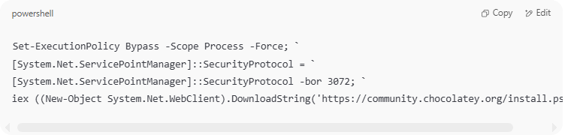
Set-ExecutionPolicy Bypass -Scope Process -Force; `
[System.Net.ServicePointManager]::SecurityProtocol = `
[System.Net.ServicePointManager]::SecurityProtocol -bor 3072; `
iex ((New-Object System.Net.WebClient).DownloadString('https://community.chocolatey.org/install.ps1'))

- Wait for it to complete.
After that, you can use the choco command from any terminal.

🔒 Is Chocolatey Safe?
# Source: AI Source: Provided by: [Data Path: Persons Table -> ID Column: 1, Name_En Column: Motasem Essam] -> From: [Chatgpt (GPT‑5 Mini)] on [1/26/2026]
Yes — it uses verified packages, checksums, and community moderation. You should still review what you're installing (like any package manager).

